Weather Data Analysis for Station AL007

Abstract
The dataset provides a detailed analysis of weather parameters, including precipitation, temperature, and atmospheric pressure across various years for station AL007. Examining the precipitation data for the year 2020, we found that the median of mean precipitation values was 0.0212 mm, indicating relatively low rainfall. Similarly, the temperature analysis for 2021 revealed that April exhibited the largest temperature discrepancy, with a difference of 26.027°C between its maximum and minimum values. In terms of atmospheric pressure, December 2019 recorded the lowest pressure value of 985.22 mbar, highlighting a significant atmospheric event during that period at station AL007. These insights contribute to understanding climatic variability and patterns at the specific station over different years.
Here are the keywords that best summarize this conversation:
1. Precipitation Data Analysis
2. Temperature Discrepancy
3. Atmospheric Pressure Records
4. Station AL007

Precipitation

When ordering the dataset of the precipitation in ascending order, what is the median value for year 2020 for station AL007?
To find the median value of precipitation for the year 2020 at station AL007, we must first organize the precipitation data in ascending order and then identify the median value.
Data:
Here are the recorded mean precipitation values for each month in 2020:
Month | Mean Precipitation (mm)
January | 0.0098
February | 0.0083
March | 0.0257
April | 0.0209
May | 0.0169
June | 0.0439
July | 0.0052
August | 0.0178
September | 0.0642
October | 0.0572
November | 0.0215
December | 0.1003
Calculations:
1. Arrange the values in ascending order:
0.0052, 0.0083, 0.0098, 0.0169, 0.0178, 0.0209, 0.0215, 0.0257, 0.0439, 0.0572, 0.0642, 0.1003
2. Find the median:
Since there are 12 values, the median will be the average of the 6th and 7th values:
Median = (0.0209 + 0.0215) / 2
Median = 0.0212 mm
Conclusion:
The median value of mean precipitation for the year 2020 at station AL007 is 0.0212 mm.

Data Charts
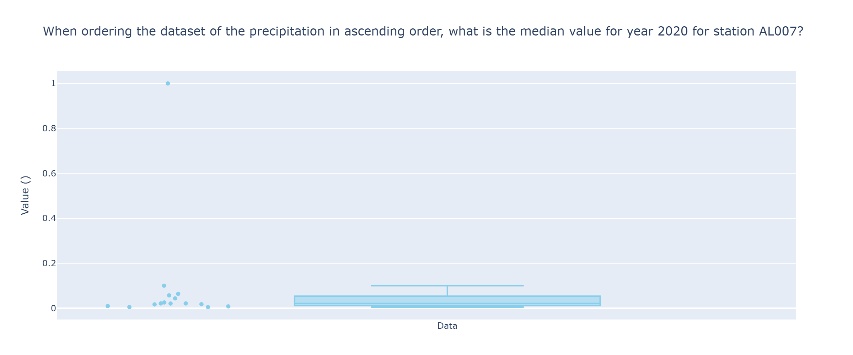

Temperature

In which month of year 2021 does the temperature show the greatest discrepancy between its maximum and minimum values for station AL007?
To find the month in 2021 with the greatest discrepancy between maximum and minimum temperature values at station AL007, we need to calculate the difference between the maximum and minimum temperature for each month and identify which month has the largest difference.
Data:
Month | Max Temperature (°C) | Min Temperature (°C)
January | 17.05 | -0.189
February | 23.458 | -0.885
March | 25.503 | 1.904
April | 28.165 | 2.138
May | 30.932 | 9.173
June | 37.164 | 14.5
July | 37.627 | 18.785
August | 40.539 | 16.683
September | 33.588 | 16.743
October | 30.62 | 9.034
November | 26.633 | 3.048
December | 21.473 | 1.902
Calculations:
1. January:
Discrepancy = Max - Min = 17.05 - (-0.189) = 17.239°C
2. February:
Discrepancy = Max - Min = 23.458 - (-0.885) = 24.343°C
3. March:
Discrepancy = Max - Min = 25.503 - 1.904 = 23.599°C
4. April:
Discrepancy = Max - Min = 28.165 - 2.138 = 26.027°C
5. May:
Discrepancy = Max - Min = 30.932 - 9.173 = 21.759°C
6. June:
Discrepancy = Max - Min = 37.164 - 14.5 = 22.664°C
7. July:
Discrepancy = Max - Min = 37.627 - 18.785 = 18.842°C
8. August:
Discrepancy = Max - Min = 40.539 - 16.683 = 23.856°C
9. September:
Discrepancy = Max - Min = 33.588 - 16.743 = 16.845°C
10. October:
Discrepancy = Max - Min = 30.62 - 9.034 = 21.586°C
11. November:
Discrepancy = Max - Min = 26.633 - 3.048 = 23.585°C
12. December:
Discrepancy = Max - Min = 21.473 - 1.902 = 19.571°C
Conclusion:
The month with the greatest discrepancy between maximum and minimum temperature values for station AL007 in 2021 is April, with a difference of 26.027°C.
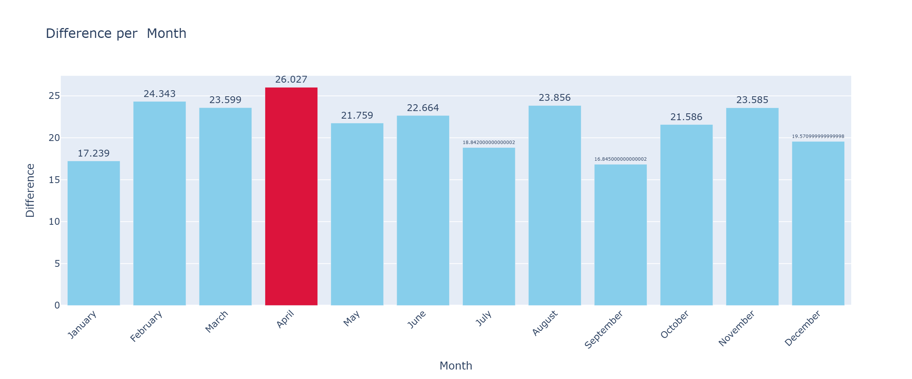

Pressure

In which month of the year 2019 was the lowest value of the pressure recorded for station AL007?
To determine the month in 2019 with the lowest atmospheric pressure recorded for station AL007, we need to examine the minimum pressure values for each month of that year.
Data:
Here are the minimum pressure values for each month in 2019:
Month | Min Pressure (mbar)
January | 987.49
February | 997.99
March | 1009.5
April | 997.69
May | 999.37
June | 1007.5
July | 997.21
August | 1008.98
September | 1010.32
October | 1003.66
November | 991.23
December | 985.22
Calculations:
- We need to identify the lowest value from the "Min Pressure (mbar)" column.
Conclusion:
The lowest pressure recorded in 2019 was 985.22 mbar in December. Therefore, December was the month with the lowest atmospheric pressure for station AL007 in 2019.

Data Charts
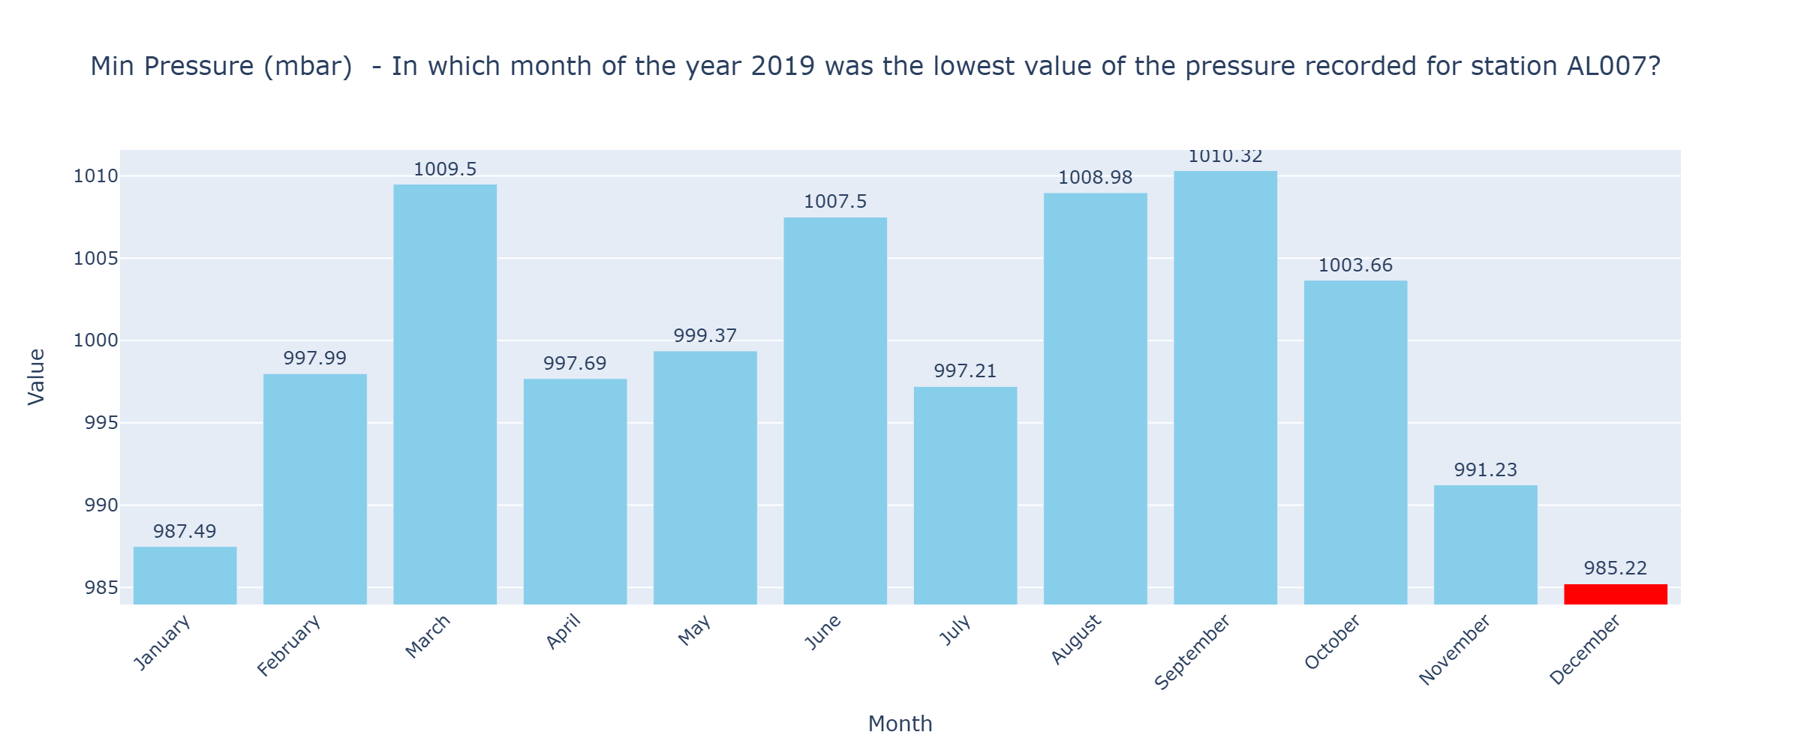

Data
Summary Table:
Question | Numerical Data
- median_precipitation | 2020,0.0212 mm
- greatest_temperature_discrepancy | April 2021,26.027°C
- lowest_pressure_recorded | December 2019,985.22 mbar

Conclusion
### Conclusion:
Based on the analysis of the precipitation, temperature, and atmospheric pressure data for station AL007, we identified several key insights. For the year 2020, the median precipitation value was found to be 0.0212 mm. In 2021, April had the greatest discrepancy between maximum and minimum temperature values at 26.027°C, indicating significant temperature variation during that month. Additionally, December 2019 recorded the lowest atmospheric pressure at 985.22 mbar, making it the month with the lowest pressure for that year. These findings help us understand the climatic patterns and variations at station AL007 across different years.

